**BattleShip**

by  
Florian Gartner,

Martin Hutter,

Thurid Reichel,

Georg Schmitzer,

Andreas Staudacher

Contents

Project Team 3

Work packages 3

CSS design - FXML design (Splash, Menu, Edit, Play, End) 3

CSS design - FXML design (Connect, Highscores, Replay, Credits) 3

Edit mode 3

Splash screen + Welcome screen 3

Multiplayer online functionality (=socket programming) 4

Highscore list 4

Test writing – Spec writing 4

Battlenames – Creation 4

In.game-graphics and sounds 5

Presentation – Preperation 5

Documentation 5

Bugfixing 5

Project cost calculation 5

Paper Mockup 6

Splash 8

Menu 8

Edit 8

Play 8

End 8

Connect 8

Highscores **Fehler! Textmarke nicht definiert.**

Replay 9

Credits 9

Manual 9

START Screen 9

Start a new Game 10

Placing your ships – EDIT 11

Battle-Screen 12

Result-Screen of the latest battle 12

HIGH SCORE 13

REPLAY SCREEN 13

CREDITS 14

# Project Team

Teamname:

DasTeamDasMirPersoenlichAmBestenGefaellt (DTDMPABG)

Florian Gartner - GUI Designer/Programmer

Martin Hutter - Edit/Highscore Mode Programmer

Thurid Reichel - Creation Programmer

Georg Schmitzer - Co GUI Designer/Programmer

Andreas Staudacher - Team Leader/Code Specialist

## Work packages

### CSS design - FXML design (Splash, Menu, Edit, Play, End)

making a pretty looking game, using css and fxml

Estimated time: 12 Ph

Responsible: Florian Gartner, Thurid Reichel

### CSS design - FXML design (Connect, Highscores, Replay, Credits)

making a pretty looking game, using css and fxml

Estimated time: 12 Ph

Responsible: Florian Gartner, Georg Schmitzer

### Edit mode

At the start of the game you are able to position your ships.

Estimated time: 6 Ph

Responsible: Martin Hutter, Andreas Staudacher

### Splash screen + Welcome screen

Show an animation at the start of the application.

On interaction show the main menu.

Estimated time: 4 Ph

Responsible: Florian Gartner

### 

### Multiplayer online functionality (=socket programming)

Establishing an TCP/IP connection to communicate with another instance of the program.

Estimated time: 14 Ph

Responsible: Andreas Staudacher

### Highscore list

Show a list of the top 10 fastest games (number of moves) and be able to replay them. (battlename + moves)

Estimated time: 8 Ph

Responsible: Martin Hutter, Thurid Reichel

### Test writing – Spec writing

Writing automated tests to confirm the correct functionality of the program.

Estimated time: 6 Ph

Responsible: Florian Gartner, Andreas Staudacher

### Battle names – Creation

Creating a set of words of which battle-names get generated randomly.

Estimated time: 4 Ph

Responsible: Thurid Reichel, Georg Schmitzer

### In game-graphics and sounds

Updating the current graphics and playing sounds depending on what is currently happening in the game.

Estimated time: 10 Ph

Responsible: Florian Gartner, Andreas Staudacher

### Presentation – Preparation

Preparing a nice presentation for our client, Mr. Ladstätter.

Estimated time: 4 Ph

Responsible: Florian Gartner, Martin Hutter, Thurid Reichel, Georg Schmitzer, Andreas Staudacher

### Documentation

Creating a comprehensible, complete documentation of the project.

Estimated time: 10 Ph

Responsible: Florian Gartner, Martin Hutter, Thurid Reichel, Andreas Staudacher, Georg Schmitzer

### 

### Bug fixing

Estimated time: 28 h

Responsible: Florian Gartner, Martin Hutter, Thurid Reichel, Andreas Staudacher, Georg Schmitzer

# Project cost calculation

Total amount of Ph = 112

Costs per hour: 80 €

Total costs: 8960 €

# Paper Mockup

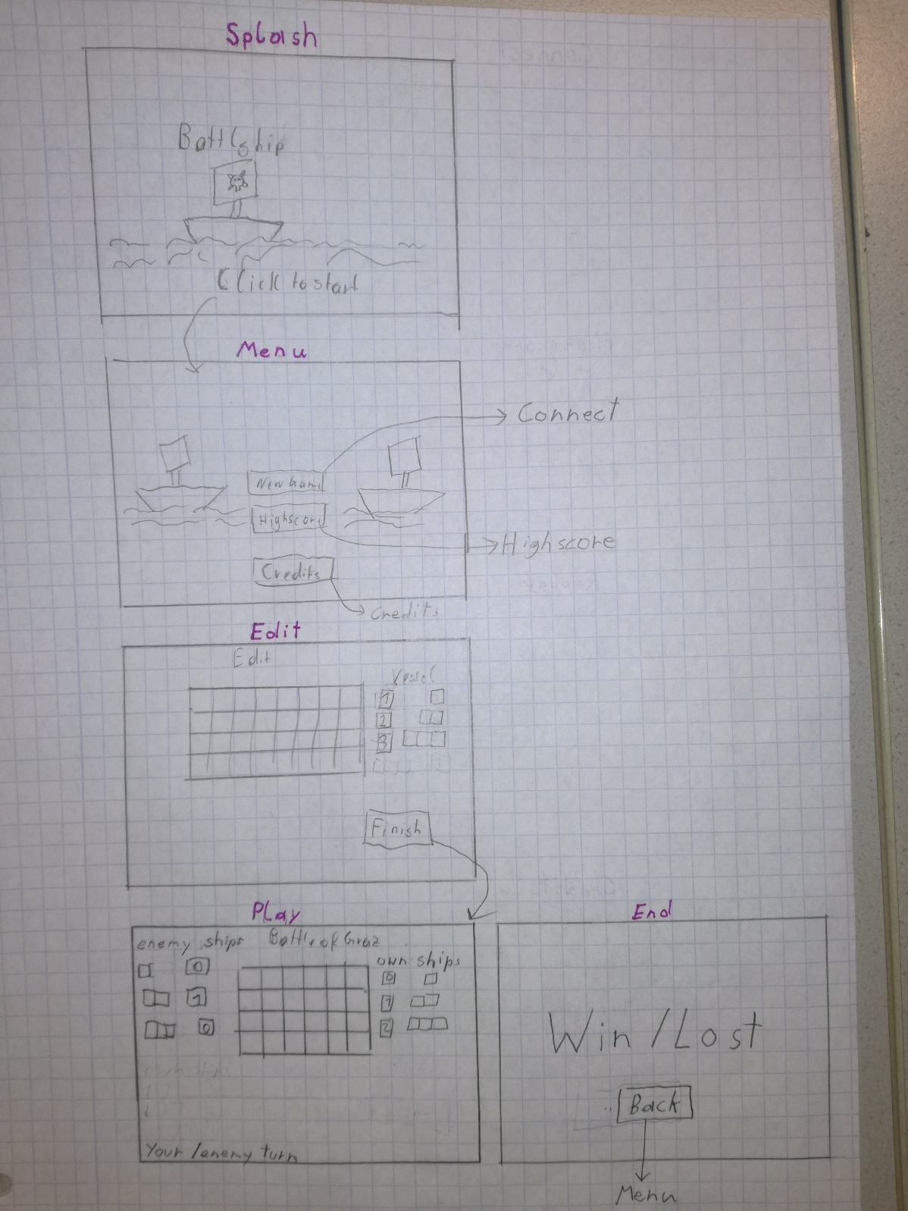

Abbildung : Mockup1

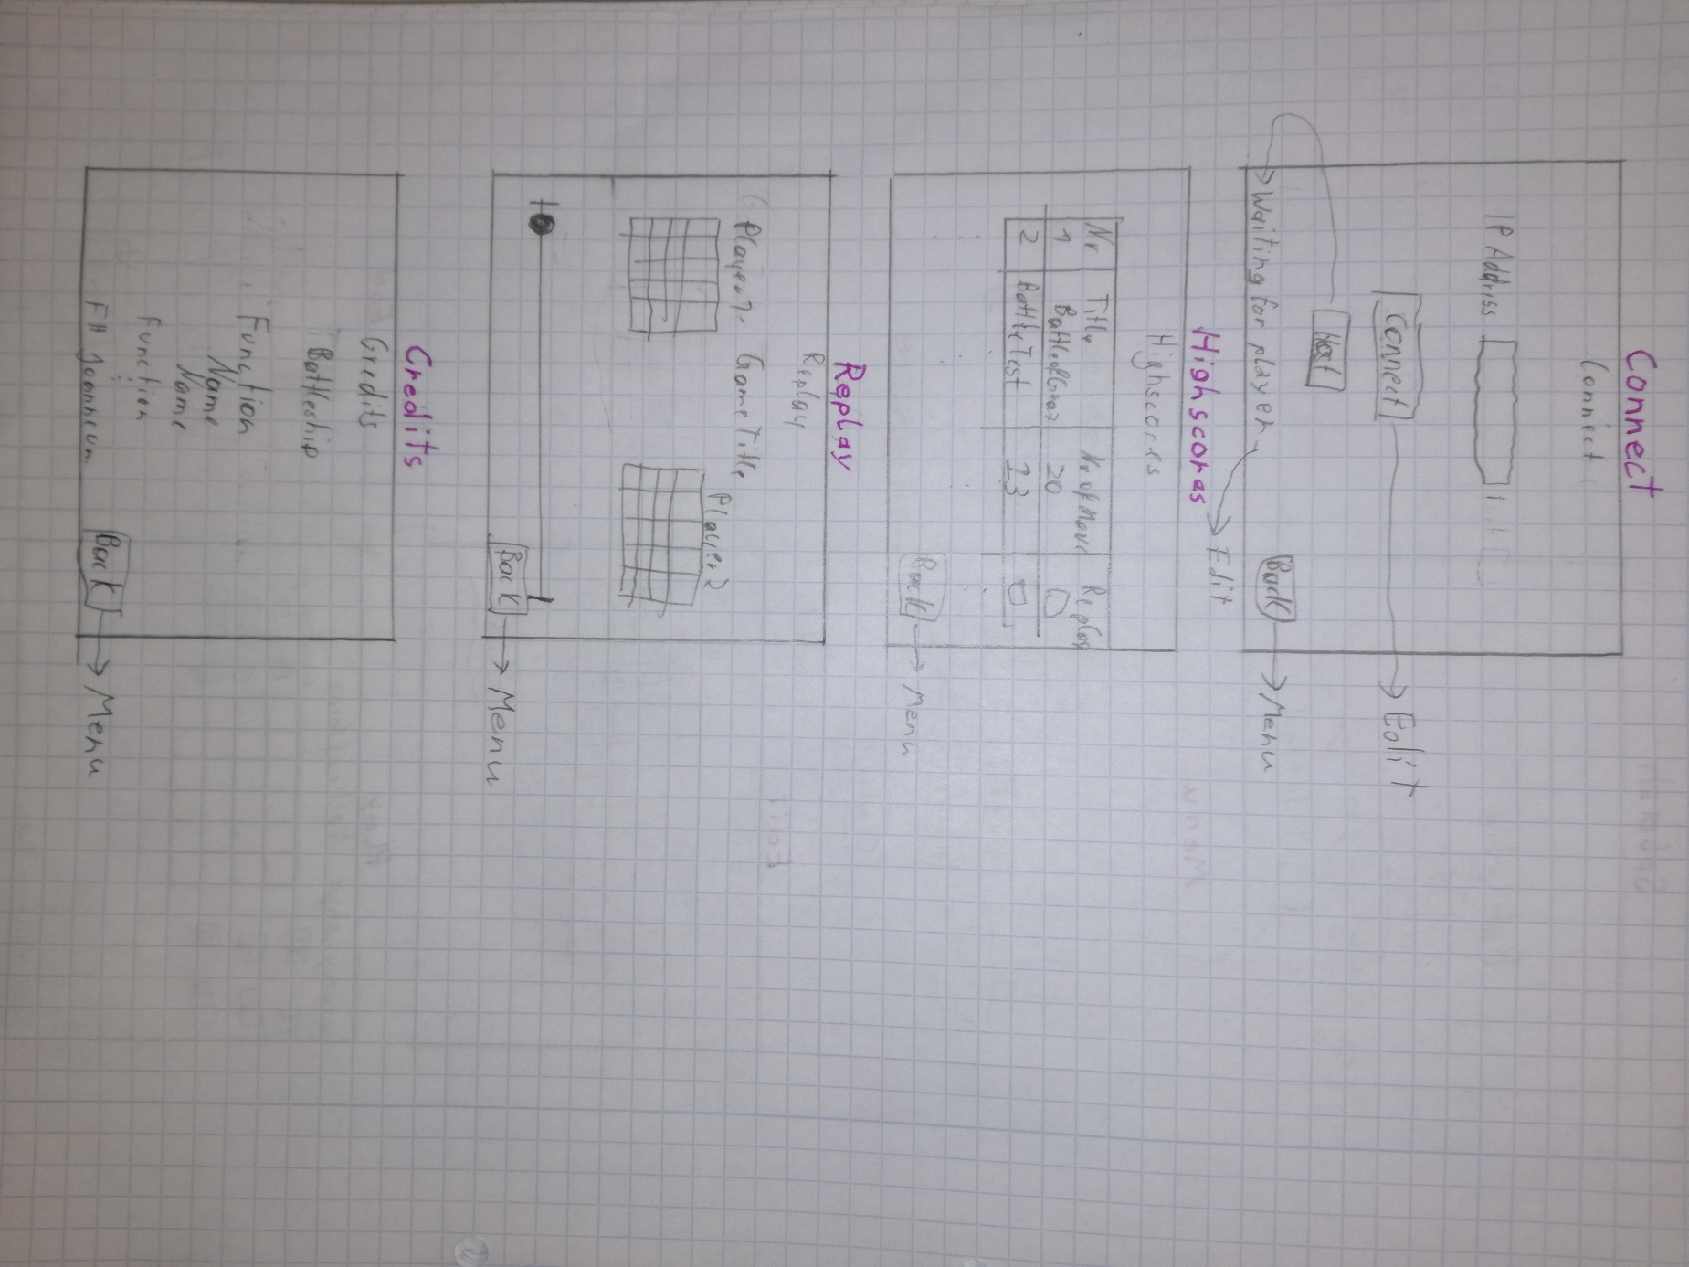

Abbildung 2-Mockup2

## Splash

Animated background. When you click anywhere or press any button you get to the Menu.

## Menu

Same animated background as Splash. With the New Game button, you get to Connect.

The Highscores button brings you to the Highscores.

With the Credits button you get to the Credits.

## Edit

You can choose the type of ship on the right by clicking. Selected ship type gets highlighted by a colour border or glow. Left of the ship types you see how many moor ships you can place

You place a ship by clicking on the battlefield.

After all ships have been placed the Finish button gets active and by clicking it you get to Connect.

## Play

The title of the game (example: Battle of Graz) is displayed at the top. Enemy and own remaining ships are displayed left and right of the enemy’s battlefield. The battlefield changes colour, depending on who’s turn it is and this information is also displayed in the bottom left.

When all the ships of one player are destroyed you get to End.

## End

Displays win or lost depending on if you win or lost. The Back button brings you back to Menu.

If you won the text is green, else it is red.

## Connect

When you click Host, a text in the bottom left appears saying “Waiting for player”, until another player connects. Then you get to Play.

When you enter an IP Address and click on connect you get to Play.

Back button brings you to Menu.

## Highscores

Displays list of top 10 games. Replay button on each game brings you to Replay.

Back button brings you to Menu.

## Replay

Sliding the slider displays the moves on the battlefields. The player that won is green. The other is red. Back button leads to Menu.

## Credits

List of who did what. FH Joanneum Logo at the bottom.

# Manual

You need to install Java to enable the Battleship-App.

When the BattleShipFxApp is started, the first screen is loaded.

## START Screen

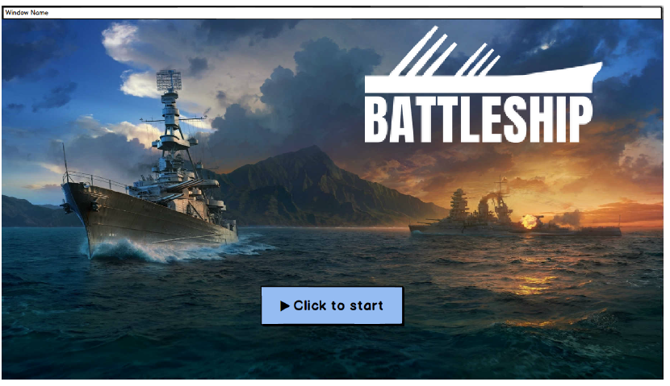

Abbildung 3-Start Screen

Click the button “Click to start” to start the game.

You get forwarded to the next screen.

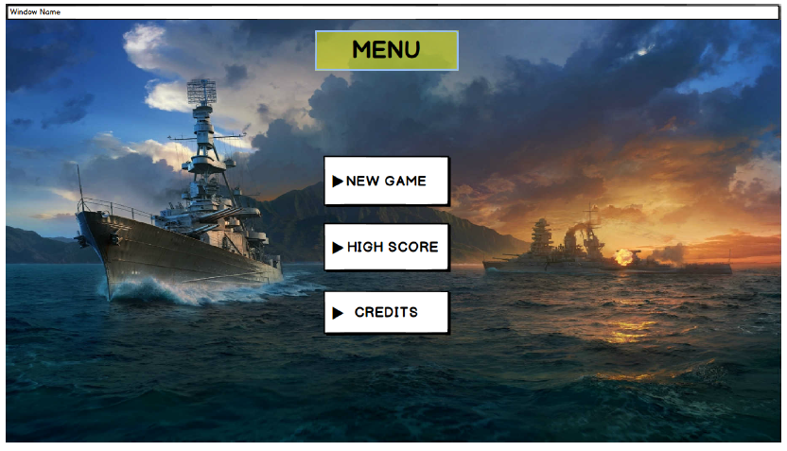

Abbildung -Main Menu

Here you have the choice to either start a new game – button “NEW GAME”, check the last 10 Highscores - button “HIGH SCORE” (the battles with the leas turns) or have a look to the credits – button “CREDITS”.

## Start a new Game

After using the button “NEW GAME”, you will be lead to the following view.

First, one of the 2 players have to press the HOST button – the game will be hosted on his computer.

The second player, inserts the IP address of the host in the field “IP Address” and then needs to push “Start Connection” and will be forwarded to the EDIT Mode.

At the bottom left you can see the state of the other player. At the bottom right, you can go back to the previous screen.

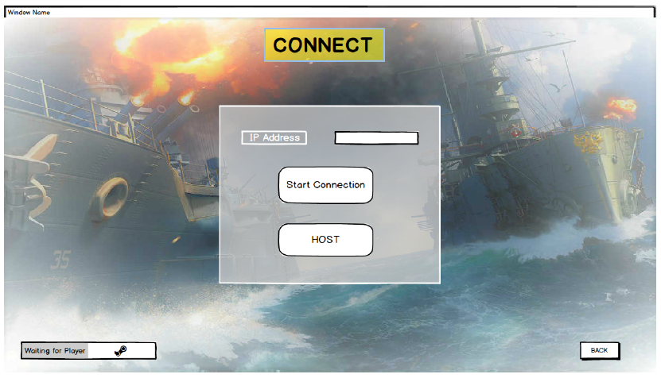

Abbildung 5 - Connect-Screen

## Placing your ships – EDIT

There are three ships containing one cell, 2 ships consisting of 2 cells each and one ship holding 3 cells that can be placed on the Battlefield.

Select the ship and chose the cell on the Battlefield– if you want to change the random alignment, you can use the buttons “HORIZONTAL” or “VERTICAL”. When you have placed your ships, press “FINISH” to continue.

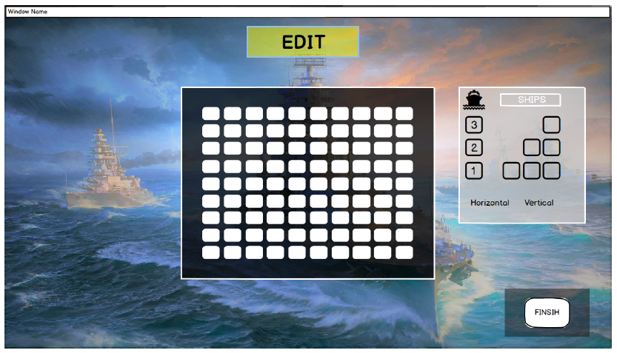

Abbildung 6 - Edit Screen

## 

## Battle-Screen

The battle will take place here. You can select a field in the Battlefield where you want to “attack” your opponent. Displays for the remaining ships of your enemy and your own ships can be seen left/right of the battlefield to monitor the progress of the game. The button back will redirect you to the main menu.

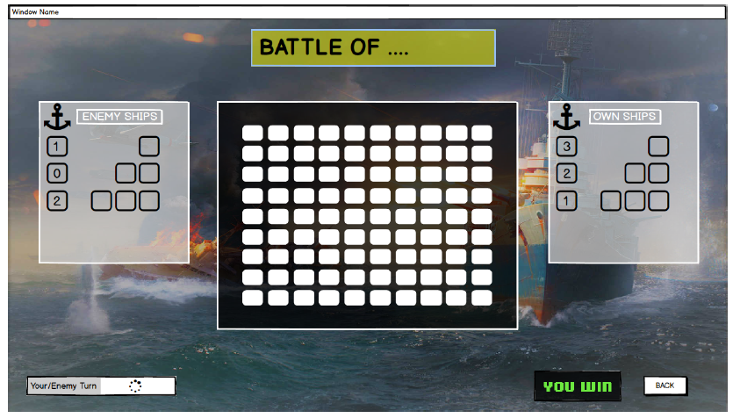

Abbildung 7 - Battle-Screen

## Result-Screen of the latest battle

If all ships of one player are destroyed, the screen will change and display whether “You win” or “You Lose”. Via the “back” button you get to the main menu screen, from where you are able to visit the HIGH SCORE view. There you can review the 10 best battles (the ones with the smallest number of moves) and can select to show a replay-version.

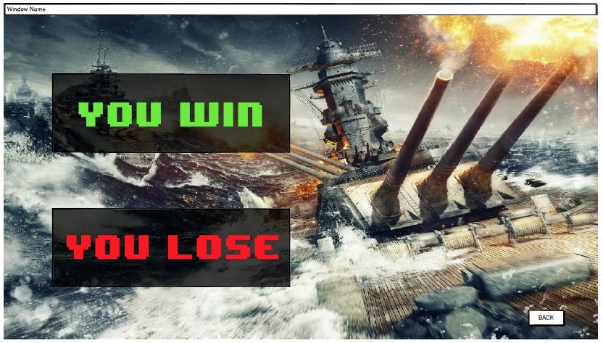

Abbildung 8 – Result

## 

## HIGH SCORE

Here you can review the 10 best battles (the ones with the smallest number of moves) and can select to show a replay-version, when you click the button on the very right.

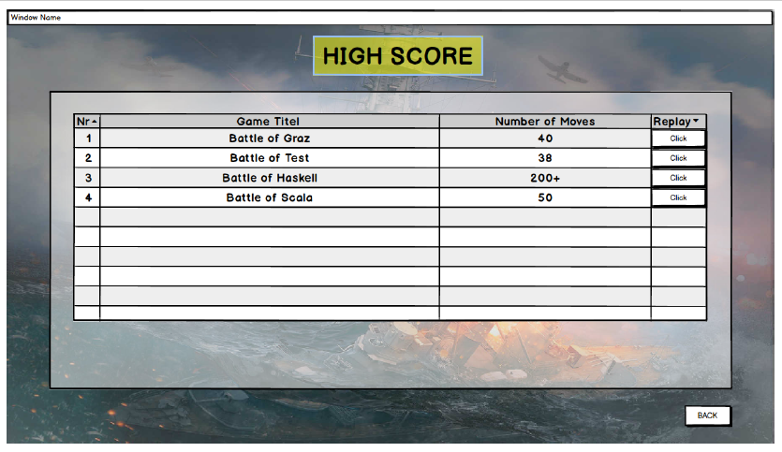

Abbildung 9 – Highscore

## REPLAY SCREEN

On the Replay-Screen you will find a slider at the bottom to choose a state of the selected replayed battle.

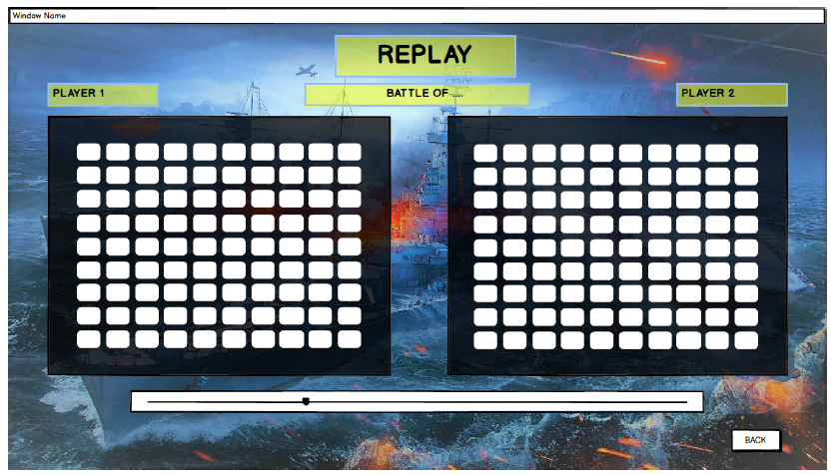

Abbildung 10 - Replay Battles

## CREDITS

From the main menu you can reach the screen with the credits displayed – from there you can reconnect to the main menu by clicking “back” at the right bottom.

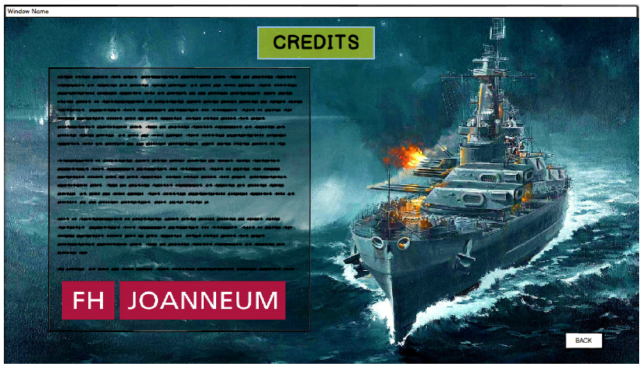

Abbildung - Credits